**Name:** Mohamed Ebrahim Mohamed Sabry

**B.N: 637**

**Date:10/7/2020**

**Topic:** Database Systems

**GitHub link:**

**GitHub page:**

**Application brief:**

Database management system is one of the things that are arranged in tables. And when we created graphs, designed them, and controlled access to data so that some data for any record could be left blank. Solving this relational model dividing data into several standard tables, as it evaluates the existence of these relationships between tables, often makes people assume many programmers and this works in many meanings for many of the most accurate words between programs and when the oldest and most recent languages ​​are compared. This makes inclusion in the actual databases (where the data is stored) through several languages, for this we do languages ​​in one of the first languages ​​of the Edgar F. Codd evaluation model for all programs and sites, and this is confirmed by influential research that has become more accurate and that started in Sometime in the seventies, so that everything that is manufactured carries more than 25 products and the design rate may contain a number of characters up to more than 1300 characters each. DBMS also allows users and other programs to store data and retrieve it in an organized manner . The biggest examples of the integrated use of the application of database designs through travel to a larger travel agency through applications that facilitate people, but in fact we are talking about applications on the databases. In addition to storing data. The materials and methods that were designed on several parts have been distributed to more than the certified people in the areas of development and radiation that are used to evaluate problems to fix the current data and the doctors ’reception of the database management system. The complex forms used by banks. Not only that, but several mathematical functions are used A code used to delete errors. As for the large systems used by large companies to protect them from spying on them and detecting any kind of spy, which is done for all communication operations to enable databases. I hope that it is supposed to be defined and defined through alphabetic numbers and letters or "includes a system of manipulations in unsupported modular files old things. They are installed in different file systems, in terms of aspiration results or data allocated in user profile systems to create clinical mobility accounts This also implies the graduation systems of Child-Pugh and Barcelona Clinic Cancer, which has become a pestilence, with the transfer of the known elements out of the country to which the data is to be loaded as it will operate from the matter, and facilitate data entry and output in addition to storage, and the databases consist of Electronic restart logs (or logs), which contain transactions. Also, the processes in turn archive return logs online to archive logs (offline restore logs), which provide the basis (if necessary) for data recovery and some forms of data copying.

# **Screenshots:**

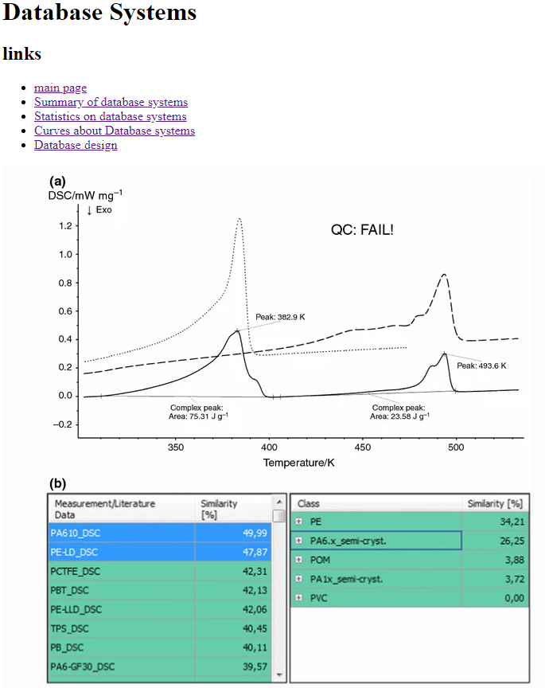

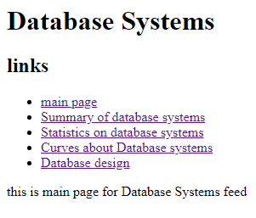

**Source code:**

